GHANA INSTITUTE OF JOURNALISM
ADVERTISING AND SOCIETY (GROUP 6, SUBGROUP 3)

NAME | INDEX NUMBERS
PORTIA OFOTSUWA DADEBOE | BACS21978
EMMANUEL ASIEME AYINE | BACS21932
NATASHA DZAMESI | BACS211000
JAISEY LAWRENCIA EMEFA | BACS211036
BERNICE BONSI | BACS21963
ZAINABU ABDULLAHI JUMIA | BACS 21810
PATIENCE AMISAH BABA | BACS21948
BUOBU EVELYN ADJOA | BACS21970
KATAKITI AKUA MILLICENT | BACS211040
ABIGAIL ANSAH ASIEDU BACS21928

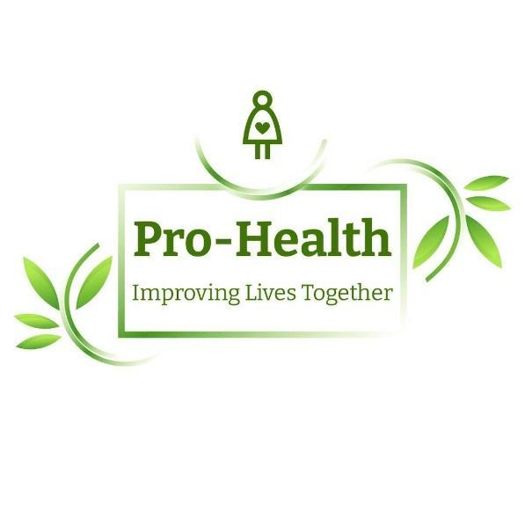

PROFILE OF ORGANIZATION
PRO-HEALTH foundation is a non-profit, non-governmental organization Instituted in 2010 by a group of young passionate health volunteers on a mission to address the poor health and dietary status of people particularly the youth of Ghana. Exposed to the reality of poor health conditions of the majority of the youth through volunteerism, we pride ourselves on creating awareness about the poor state of health, providing expert knowledge about health through our partners, and embarking on anti-poor health behavior campaigns. With partners such as the World Health Organization (WHO), National Health Service (NHS), Health Focus Ghana (HFG), and South Africa Health Needs Foundation (SA-NF), we have successfully implemented over 100 health campaigns/projects that have affected a lot of lives and captured the attention of the world.
VISION
PRO-HEALTH foundation seeks to serve as a catalyst in bringing sustainable change in the healthy lives of Ghanaians.
MISSION
Our mission is to build long-term partnerships with local communities and health systems to facilitate sustainable, innovative, and life-saving health and dietary care for the youth.
CORE VALUES
Collaboration
Service
Creative Leadership
Integrity
TOPIC: ALCOHOLISM AND HEART CONDITIONS
1.0 BACKGROUND
Alcohol consumption is predominant and socially accepted as an enjoyable activity in many countries around the world (Young et al., 2006). This resonates with the United Nations’ statement that “Beverage alcohol is the substance most widely consumed worldwide” (United Nations, 2004). WHO stated that the world’s highest alcohol consumption level is found in the developing world (WHO, 2011). Also, a recent demographic and health survey conducted by the Ghana Statistical Service and Ghana Health Service established, 37% of males and 17% of females in Ghana reported being current alcohol users (Ghana Statistical Service & Ghana Health Service, 2019). This alarming rate of alcohol consumption has renewed the long-standing concern about the consequences of its consumption. Alcohol consumption, particularly heavier drinking, is an important risk factor for many health problems and, thus, is a major contributor to the global burden of disease. In fact, alcohol is a necessary underlying cause for more than 30 conditions and a contributing factor to many more. One of the most common diseases associated with alcoholism is a heart condition. Excessive alcohol intake can lead to high blood pressure, heart failure, or stroke. Excessive drinking can also contribute to cardiomyopathy, a disorder that affects the heart muscle. With these associated challenges, it is imperative for a well-designed campaign to be carried out towards minimizing its consumption.
PROBLEM STATEMENT
The WHO (2014) noted that the harmful use of alcohol results in approximately 2.5 million deaths each year. However, there is little information on the harmful health effects of alcoholism particularly its heart-related conditions. In this campaign, PRO-HEALTH Foundation aims to reduce the health burden caused by the harmful use of alcohol and, thereby, to save lives, reduce disease and prevent injuries. This will be achieved through a counter advertisement strategy that creates the needed awareness.
OBJECTIVES
- Within the period of three years, from the commencement of the campaign, Pro- HEALTH Foundation intends to achieve a 30% increase in the awareness creation on matters of alcoholism and its negative effects on human health.
- By December 2026, the campaign aims at achieving a reduction in the intake of alcohol among the youth and age from the current 41% to 20%.
- To ensure that by December 2028, the number of heart-related diseases arising from the intake of alcohol is reduced by 30%.

TARGET POPULATION
This counter ad campaign is centered on alcoholism and its resultant effects on heart-related diseases. Thus, the study population comprises all consumers of alcoholic beverages.

METHODOLOGY
Pre-Production
At this stage, the quantitative method was adopted to gather primary information about the current state of alcohol intake and its related health (heart) issues. Quantitative research involves the utilization and analysis of numerical data using specific statistical techniques to answer questions like who, how much, what, where, when, how many, and how. Through this research method, questionnaires were adopted as a special instrument in gathering data among hundred (100) respondents. The outcome of this finding helped us answer the above questions such as the type of alcohol consumed, the reason for consumption, the effects of consumption, rate of consumption among others. This primary information made it possible for us to design a precise message for our counter ad.
Production
This campaign will be produced in the form of an animated film. In our counter advertisement technique, we intend to employ the shock advertising technique in delivering the key message. Shockvertising is an innovative advertising technique that purposely attempts to gain and keep attention with horror and disgust. Levitt (1970) indicated that this type of advertisement mostly makes use of blood, internal organs, racism, and sexuality to portray horror. Therefore, with our advert focus on alcoholism and heart diseases, the technique will make it possible for us to demonstrate clearly the harmful effects of alcohol on the heart through the display of scary outlook of internal organs (heart). This will help trigger reactions from our target audience by frightening them about the negative effect of alcohol on the heart.

Post-production
Post-production, which is often referred to as ‘post’, is organizing, cutting, coloring, and editing in production. This is where all our footage will be constructed and the final touches; the elements that really make the video pop will be added to get the final PRODUCT. The Foundation intends to promote this campaign through Television ( TV3, UTV, Citi TV) for a one-year period, Radio ( Peace FM, Joy FM, Citi FM), which will also be aired for a period of two years. For some selected social media platforms ( Twitter, Facebook, Instagram), the campaign will keep running on these social media platforms until December 2028, to ensure that we are able to achieve our long-term objective; objective number 3.

BUDGET
PRE-PRODUCTION

ITEM | QUANTITY | AMOUNT ( GH₵ )
Questionnaires | 100 | 100
field trip | 10 | 200
Data for research | - | 50

total for pre-production = GH₵ 350

PRODUCTION

ITEM | QUANTITY | AMOUNT ( GH₵ )
Animator | 1 | 450
Storyboard artist | 1 | 200
Recordist / Sound | 1 | 150
Voice actors | 3 | 200

The total amount for production = GH₵ 1,000

POST PRODUCTION

ITEM | QUANTITY | AMOUNT ( GH₵ )
Tv advertisement ( tv3,utv,Citi tv | 1 year | 7,500
Radio ads ( peace FM, joy FM, Citi FM ) | 1 year | 8,000
Social media ( Facebook, Instagram, Twitter ) | 1 year | 1,000
Miscellaneous |  | 200

the total amount for post-production =GH₵ 16,7000

GET IN TOUCH
EMAIL: prohealthfoundation@gmail.com
FACEBOOK: prohealth foundation Gij
TWITTER: prohealthfoundation1
INSTAGRAM: pro_healthgh
BLOG: profoundation.health.blog

PICTURES

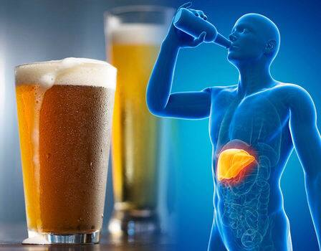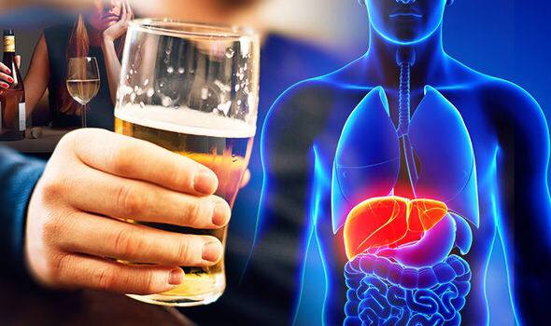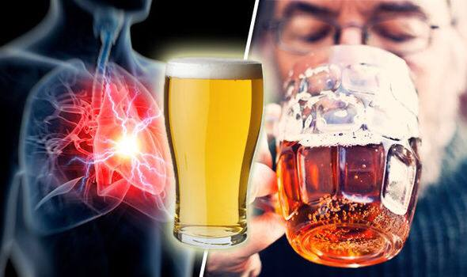

References
Levitt, T. (1970). The morality (?) of advertising, Harvard Business Review, 37 (July/Aug), pp. 57-84.
World Health Organization (2004).Global status report on alcohol 2004. Geneva (http://www.who.int/substance_abuse/publications/global_status_report_2004_overvi ew.pdf, accessed 21 November 2014).
World Health Organization (2014).Global status report on alcohol and health 2014. Geneva. (http://www.who.int/substance_abuse/publications/global_alcohol_report/en/
accessed 21 November 2014).

